This Room is a Pocket of
Nuclear Awareness
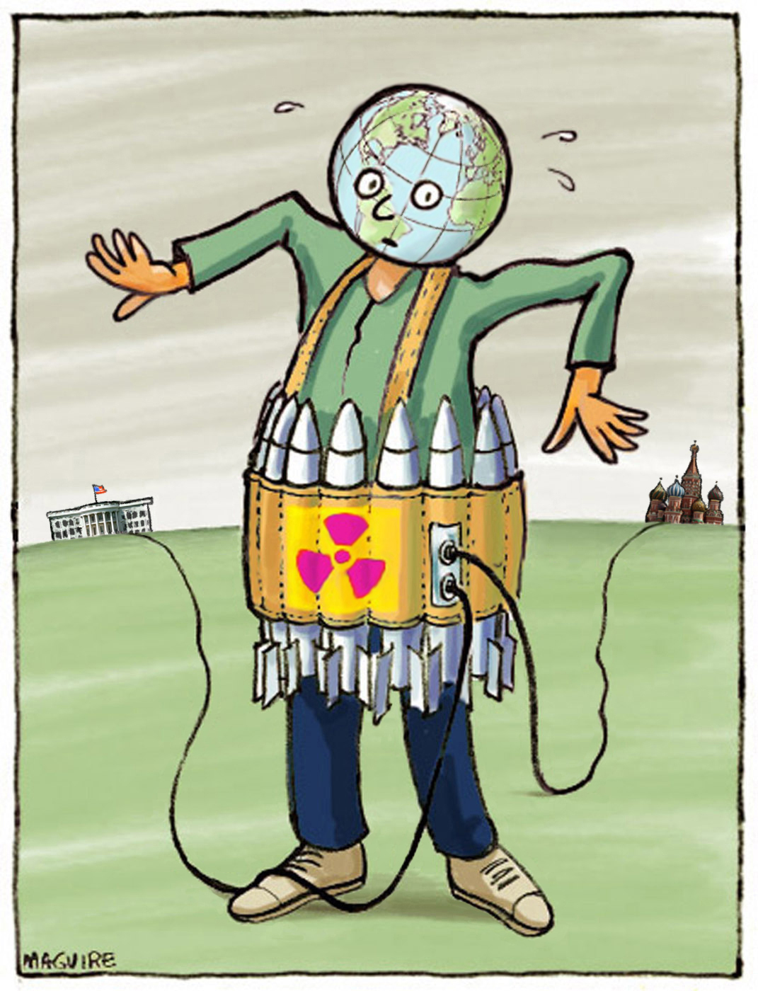
I have committed to educate myself on the risk posed by nuclear weapons and to encourage others to do the same. Please join me in making FloMo a larger “pocket of nuclear awareness” which then can spread to all of Stanford. Who knows? We might even change the world. To learn more, contact NuclearRisk@stanford.edu
Student Name(s) and StudentAddress@stanford.edu
NuclearRisk.org

